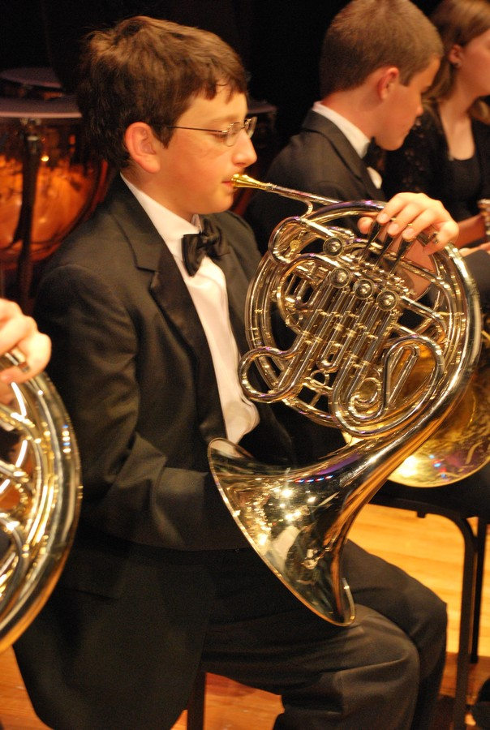

**UNION SYMPHONY STUDENTS EXCEL!**

Many congratulations!

Dorian Fiddles, Union Academy Talent Show/First Place

Lakshmi Prakash, Western Regional Senior Orchestra Honors

Delaney Brigman, Western Regionals

Benjamin Laramee, 1st Chair, Tuba, Grades 9-10 All District Band

Justin Laramee, First Alternate, Flute, Grades 9-10 All District Band

Garrett McCloskey,  1st Chair All-District (Oboe)

Landon Brooks, All State

Kate Stevens (11th grade, viola) NC All State Orchestra 2012, full scholarship to Cannon Music Camp Summer 2013, and

Western Regional Honors Orchestra 2013

Kahliq McCorkle, All District Honor Band

Michael Jeffries, All District Honor Band.

Melissa Hagstedt, 1st chair All District 9/10 Honor Band and 2nd chair Honors Orchestra

Dayna Hagstedt, 5th chair All District Honor Band

Adrienne Bonar, All District Honor Band

Jessica Turcotte , All State Orchestra and Western Regionals

Rebecca Mulligan, 11/12 Grade Honor Band

Melissa Fu, 9/10 Grade Honor Band

Kyle Johnson,  9/10 Grade Honor Band

Philips Clarke,  9/10 Grade Honor Band

Walter Bonar,  9/10 Grade Honor Band

Matthew Bishop, 1st chair All District Middle School Concert Band

Mikaela Austin, All District Middle School Concert Band

Brad Williamson, All District Middle School Concert Band

Elise Gilliam, CMS Middle School Honors Orchestra