USYO “Wear Your Story” Fundraiser

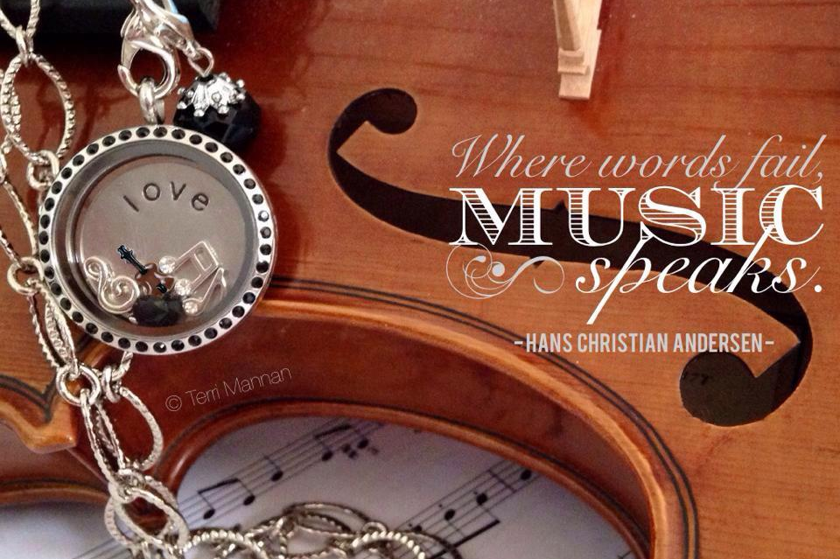

Introducing an exciting new fundraiser for USYO! From now through Labor Day Music Camp and the Labor Day Concert, you have the opportunity to design a personalized locket for yourself or a loved one and 50% of all profits will go to USYO. This is a terrific opportunity to create a beautiful, meaningful piece of jewelry that tells your story and at the same time help out USYO.

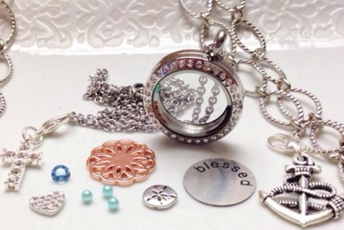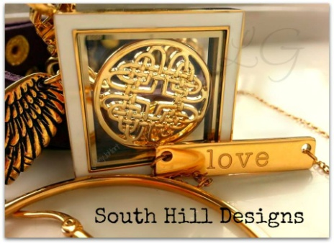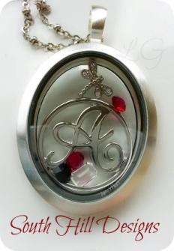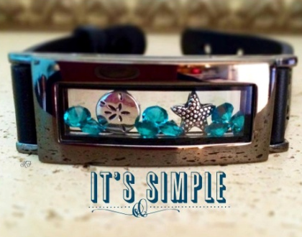

Here’s how:
    - Select a locket
    - Add a decorative screen or a word coin
    - Fill with charms that tell your story
    - Choose a chain
    - Add a droplet

For further information contact: Laurie Liss, South Hill Designs Independent Artist
704-621-2882 lisslands@gmail.com
www.facebook.com/LocketsofYourLife

To order now, click the link: Design Your USYO Jewelry

